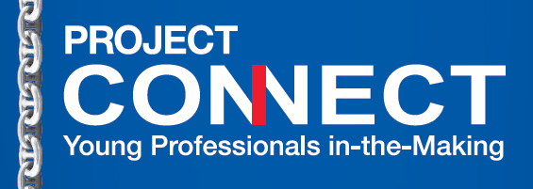

MEMBERSHIP FORM
Welcome to the NPO PROJECT CONNECT: Your donation will help enhance youth employability in Greece. By joining us, together -- we are cultivating the next generation workforce -- and thus sustaining excellence in Greek Shipping. We do this thru educating children about maritime and life at sea through the Adopt a Ship Program and we also help prepare shipping students with opportunities of learning to work, in work-study programs in shipping companies.

Please return the completed Membership Form & your company logo to bridge@project-connect.gr. For most companies, the donation is tax deductible. Please confer with your accountant (Αστική Μη Κερδοσκοπική Εταιρεία).

Company Name:

Company Address:

Contact Person & Position:

Tel Number:
E-mail:

Select type of Donation (Companies that enroll vessels for Adopt a Ship must tick the “Member” box):
- Supporter: 100€, 200€, 300€, or 400 € one time donation that helps fund the cost of administering the Adopt a Ship maritime educational program and Project Connect activities like Internship Awards and self-development events.
- Member: annual donation 500€, helps fund the administering of the Adopt a Ship program, covers 2 enrolled vessels, Work-Study Programs, Member Kits, gives you direct access to the online CV Database of available Candidates, who have been pre-screened & guided on expectations in an office setting. For more than 2 enrolled vessels, additional 100 euros fee per vessel, per year.
- Sponsor: Fund a specific event like our work ethic “CARE” workshop, “Internship in memory of (someone special)”. The amount is according to a budget and may be paid directly.
Effect contribution to: PROJECT CONNECT Include remarks: Name & Type of Donation

BANK: PIRAEUS BANK - Glyfada City Plaza Branch
ACCT NO: 6916-137143484 IBAN: GR510 1719160006916137143484 Swift: PIRBGRAA

What’s the ship’s chain logo about? The chain has been created for PC by the Artist Eva Divari who travelled on ships. We believe that an employee is like a link in a chain. If one link breaks, it affects the chain.
We aim to ensure that our new entry to a shipping company can connect well with that company thru knowing his place and his individual responsibility to perform with excellence.

Thank you, in advance, for joining. Best wishes for your company to always excel,
PROJECT CONNECT

